Lakehurst Honker

**Newsletter for the Lakehurst West Homeowners Association**

**(720) 945-9126 | hoa.lakehurstwest@gmail.com**

**March 2018 www.lakehurstwest.org**

**Meet the Board!**

Lakehurst

Honker

**Newsletter for the**

**Lakehurst West Homeowners Association**

**720-945-9462**

**www.lakehurstwest.org**

**We are proud to announce our newest members of the board.**

Before we introduce our newest members, let us extend a thank you to our past board members:

* **Joy Berrenberg,** Vice President. Joy was instrumental with her rapport with Foothills and zoning. She played a major role in the fencing at Donkey hill making it a safer place for all.
* **Bonnie Griffith**, Treasurer. Bonnie was skilled in taking on the responsibility of our accounts. Her love of the Honker newsletter was apparent.
* **Mary Koglin,** Secretary. For the past 4 years Mary served LWHOA, jotting down our records as fast as she could, which was not an easy task. She continues on as our Welcoming Committee Chairperson.
* ****Mary Smith**, for her continuous devotion as our Block Captain. Her efforts to this have extended many years, of which we are grateful for her services.

*We thank you all for volunteering to this community.*

*Your efforts are well recognized and greatly appreciated*.

This year the positions have been taken on with some familiar faces:

* **Mark Gray**, Vice President. Mark and his family have lived in Lakehurst for 5 years. They are very involved at Peiffer where their two children attend school. Mark has been photographing for the LWHOA.
* **Jeff & Barb Moreau**, Secretaries. Jeff & Barb are standing in as a couple. They have lived in Lakehurst for 19 years and have two daughters. Jeff is our Grill Master at LWHOA events.
* **Amy Teufert,** Treasurer, her family has lived in the area for 11 years and has been actively involved in HOA events in the past.
* **Amy Santistevan**, Web Site. Amy has offered to donate her time keeping tabs on the site. Her son attended Peiffer Elementary and volunteers delivering newsletters.
* **Gina Petrini**, Newsletter. Gina holds a place on the Peiffer Student Wellness Committee, and helps moderate the Peiffer School Garden.
* **Julie & Alan Blair** have offered to attend COHOPE meetings to keep us abreast on happenings in the community.
* **Attention Block Captains!!!**

Once again thank you to all the good people who have given their time to deliver the Honker. Many have volunteered for years.

**\*\*\*This year we are asking them to knock on doors and get a tally of those that would like to continue to receive the newsletter. In an effort to cut costs and save paper we are asking homeowners to provide emails as a way to receive our newsletter.**

We are more than happy to hand out paper copies if you wish. Event notices will be emailed as well. If you do not wish to receive the newsletter, please contact us at 720-945-9126 with your address.

**Box Tops for Peiffer Elementary**

Lakehurst

Honker

**Newsletter for the**

**Lakehurst West Homeowners Association**

**720-945-9462**

**www.lakehurstwest.org**

**Check out our newest neighborhood stopping point!**

*In an effort the support our community school we have placed a black box with the Peiffer Panther logo on the corner of Marlow and Oak Court.*

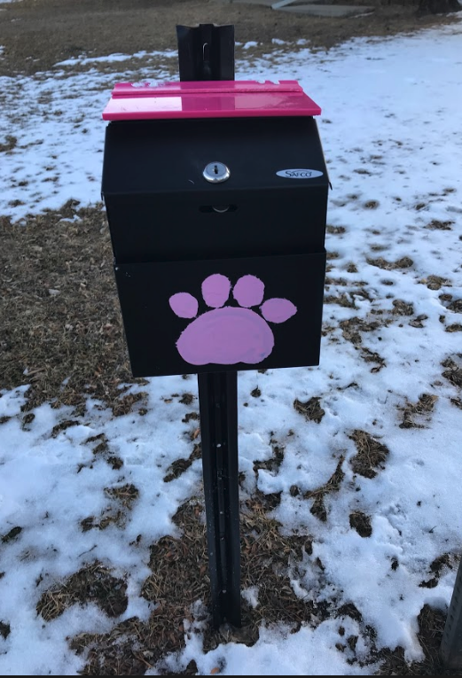For those that are unaware, Peiffer will no longer have a 6th grade class. Starting in the 2018/2019 school year, 6th grade students will be integrated to the middle schools. This now makes Peiffer a “small district school”. As such funding depends on the number of students attending each school year, this has decreased their budget significantly. In an effort to support this long standing institution in our community, we have collaborated with the PTA to help with monies by placing a Box Tops for Education collection box on the corner of Marlow and Oak Ct. Box tops can be found on most cardboard items such as cereals, crackers, and granola bars. Simply cut them off and place in the box while passing by. Past money generated from box tops in a quarter are upward of $300.00. This is a simple way to support our school! Thank you to **ED Morrison** for your support in allowing us to place the Box Top box in his yard. He too had children at Peiffer, and was very generous and willing to give us the space to help support the children. Thank you as well to Terry Burke for installation, and to Mason Shepherd for painting the logo.



***Watch for these great community events to support our children and the community.***

* **March 22nd** ***Science Fair at Peiffer Elementary* *- 5-7pm***

Come see our little scientists in action!

* **March 24nd** ***Annual Easter Egg Hunt* *- 11:00am***

Peiffer Elementary grounds. (We are looking for donations of prefilled eggs to help with this event. Please no chocolate or peanuts! These can be dropped off at the school beginning March 19th).

* **April 24th** ***Spring Choir Concert Peiffer - 6:30pm***
* **May 11th** ***Peiffer Annual PTA Plant sale – 7:30am – 3:30***
* **May 18th** ***An Evening in the Garden – 5-7pm***

If you have not seen the transformation of the old tennis courts this is a must. The utilization of this space is amazing, and is a valuable lesson in gardening for the kids. The children have turned this unused plot into a working garden, and grow the vegetables and flowers themselves.

* **May 19th** ***Open-air flea market***

Don’t like people looking in your garage during yard sales? This is a great way to get rid of your unused “clutter” and help the LWHOA and the school. $15.00 will give you two parking spaces to sell your wears. Crafts are accepted for booths. $5.00 will go to the school and $10.00 to the HOA to help with the summer concert. Set up time is 7:00am. Spaces are limited and we ask participants to reserve their space by calling 720-945-9126.

* **June 16th** ***Parade block party and Thank You luncheon for all LWHOA paid members and our block Captains.***

The parade is open to all residents of Lakehurst and friends. We encourage parade participants such as cars, children in costume, bands, or anyone with ideas for marching in this parade, to join us. Events include The Worlds Greatest Water Balloon Fight, piñata, bouncy castle, and games. Concessions available at family friendly prices. Time and location will be announced at a later date. Please RSVP to 720-945-9126.

* **July TBD** C***oncert in the Park @ Lakehurst Park - 4:00 to 6:30pm***

Enjoy music by The Margarita brothers. Concessions will be sold at family friendly prices, so make a night of it with the family and your neighbors!

*\*\*\*To put on this extremely well received event the HOA is asking your support to raise money to cover costs of the band and production. This can be done through sponsorships or donations*.

**Events - *Why are community events important?***

The board feels that bringing the community together with common interests and goals helps develop a trusting and safe environment for all. It provides the opportunity to share stories, provide information, resources, concerns, and simply to get to know each other. There is a large diversity of homeowners that have been here 30 years or more, to folks brand new to the area. We welcome all to attend the LWHOA events and join in the celebrations.

**Zoning Report**

Zoning ordinances can be viewed on our website. Reach us through the website, phone 720-945-9126, or PO box: LHWHOA – PO Box 620175 – Littleton, CO 80126.

**Donate Metal and Support the Troops**

Old appliances and other metal junk can be turned into donations for our military troops overseas. A Lakehurst neighbor, Kim Hinson, uses the money from recycling scrap metal to buy care packages. She will pick up barbeques, metal sheds, lamps, microwaves, chairs, lawn mowers, tables, golf clubs, swings, tools, nuts & bolts, pots/pans, bed frames, cars, RVs, pipes, any metal construction materials, tire rims, rebar, aluminum, steel, and copper. Text or call Kim at 303-332-1668.

**Volunteers help keep us going and growing!**

***Community involvement is essential to a successful HOA.***

The board and a handful of these hard working volunteers can achieve many of the community’s goals, but we need your additional help with clean up in the neighborhood, providing support for those unable to maintain their property, and reporting on zoning infractions when all other means have been exhausted. Watchful eyes and reporting on the needs of the community should be of a concern to all of us.

**This being said, in the past we have utilized a clean up committee. This has proven successful; however, our volunteers for this project are dwindling. To try to resolve this we are proposing a new tactic. Perhaps the reason for the lack of volunteers is due to time restrictions. We all know there is not enough of it!**

**Our idea is to have individuals or families “ADOPT an AREA” - much like the way it is done on highways and public land. There would be no restriction on times, so you can go when time permits for you personally. The board will always offer assistance and guidance.**

Areas in need will arise and present themselves as soon as Spring is approaching. We will post a signup sheet on the web site as well as contact those that have volunteered for this. Any help is greatly appreciated to keep our community tidy and beautiful.

**Dues - *Homeowner membership is $35.00 annually due in January.***

Why join? The association is voluntary and consists of residential property owners and renters if they wish. LWHOA wants us all working together to protect the value of your home and the community.

***What do your dues pay for?***

Your generosity in dues go towards the Honker newsletter, event flyers, website, PO box, phone and room rentals for meetings. This includes our Colorado HOA filings, insurance, community projects and special events. Well worth the mere $35.00 a year!



**2018 MEMBERSHIP INVOICE**

Membership in this Lakehurst neighborhood association is strictly on a volunteer basis. Members are residents who live in Lakehurst and want to keep it a great place to live!

Name: _____________________ Address: ________________________________

Phone: _____________________ Email: ___________________________________

Check if you would be interested in serving on the following committees:

🞎 Clean up 🞎 Covenants and zoning

🞎 Special events 🞎 Newsletter

🞎 Garage sale 🞎 Other _____________________

Mail form and check for $35 made out to Lakehurst West HOA at:

PO Box 620175, Littleton, 80162. Thank you!

Lakehurst West HOA General Meeting

Tuesday March 20th at 6:30 pm

Peiffer Elementary

Please join us to meet the board and catch up on issues and events. Alan Blair, PLS (Professional Licensed Surveyor) will be there to help get some answers to who is responsible for walkways as well as information from COHOPE meetings.



We’d like to hear from you!

*Do you have a neighbor seen doing*

*a selfless act for your community?*

*Do you know of someone who has shoveled sidewalks, cleaned, or helped someone in particular or with anything in the area?*

*Contact us so we can give them a shout out in the next edition of our newsletter!!!*





